

AI-Powered Predictive Threat Analysis System for Banking Networks

SYSTEM DOCUMENTATION

SUBMITTED BY,
MUTARU SANDRA WAMBUI
DCS-02-0043/2025

A SYSTEM DOCUMENTATION SUBMITTED IN PARTIAL FULFILMENT FOR THE AWARD OF DIPLOMA IN COMPUTER SCIENCE BY ZETECH UNIVERSITY

AUG 2026

DECLARATION

The content of this document is product of my own personal research as guided by unit lecturer and following the provided standards of system documentation.

Student Name: ____________________________ Sign: _________________ Date: __________

Supervisor Name: _________________________ Sign: _________________ Date: __________

DEDICATION

Firstly, I would like to thank my unit lecturer, Mr. Victor Otieno, for providing guidance, support, and valuable feedback throughout the development of this project. Secondly, I would like to express my sincere gratitude to my friends, whose encouragement, advice, and continuous support greatly contributed to the successful completion of this project. Lastly, I would like to thank my fellow students, and family members for their encouragement, cooperation, and motivation throughout the project development period.

ABSTRACT

The AI-Powered Predictive Analysis System is a web-based application developed to monitor activities, analyze data patterns, generate predictions, and provide intelligent recommendations that support decision-making. The system offers a centralized platform where users can visualize information, track activities, review historical records, and obtain analytical insights through an interactive dashboard.
The application incorporates predictive analysis techniques to evaluate collected data and generate risk indicators, confidence ratings, and recommendations based on identified patterns. Through its monitoring and reporting capabilities, the system enables users to better understand system activities, identify potential issues, and make informed decisions using generated analytical results.
The platform also includes data visualization features such as dashboards, activity feeds, reports, and graphical summaries that improve the presentation and interpretation of information. These features enhance user experience by providing clear and accessible insights into monitored activities and generated predictions.
The system was developed using HTML, CSS, and JavaScript for the frontend, Python with the Flask framework for backend development, and MySQL for database management. The project demonstrates the integration of web technologies, database systems, predictive analysis concepts, and intelligent recommendation mechanisms within a modern software application.
Overall, the AI-Powered Predictive Analysis System provides an effective and scalable solution for monitoring, analyzing, and interpreting data while supporting informed decision-making through predictive insights and automated recommendations.

DEFINITION OF KEY TERMS

AI-Powered Predictive Threat Analysis System: A web-based cybersecurity platform designed to monitor, simulate, analyze, and predict cyber threats targeting banking networks.

Banking Network: A collection of interconnected systems, servers, databases, applications, and communication channels used by financial institutions to provide banking services.

Cyber Threat: Any malicious activity or event that has the potential to compromise the confidentiality, integrity, or availability of information systems.

Threat Analysis: The process of examining security events and attack patterns to determine their potential impact and severity.

Threat Simulation: The generation of controlled cyberattack scenarios for testing, analysis, and demonstration purposes.

Risk Score: A numerical value assigned by the system to indicate the severity and potential impact of a detected threat.

Threat Severity: A classification level used to indicate the seriousness of a cyber threat, such as Low, Medium, High, or Critical.

AI Confidence: A percentage value representing the confidence level of the system's threat prediction and analysis results.

Threat Intelligence: Information collected and analyzed regarding cyber threats, attack methods, and vulnerabilities.

Threat Log: A record containing information about detected or simulated cyber threats and related security events.

Network Topology: A visual representation of devices, servers, and connections within a banking network.

Dashboard: A graphical interface that displays security statistics, threat metrics, risk indicators, and analytical information.

Security Recommendation: An action proposed by the system to reduce or mitigate identified cybersecurity risks.

User Authentication: A security mechanism used to verify user credentials before granting access to the system.

Database: A structured collection of data used to store user information, threat logs, reports, and system records.

MySQL: A relational database management system used for storing and managing system data.

Flask: A Python web framework used to develop the backend components of the application.

Frontend: The visual and interactive part of the system developed using HTML, CSS, and JavaScript.

Backend: The server-side component responsible for processing requests, executing business logic, and communicating with the database.

Cybersecurity: The practice of protecting systems, networks, and data from cyberattacks and unauthorized access.

Web Application: A software application accessed through a web browser over a network connection.

ABBREVIATIONS AND ACRONYMS

AI – Artificial Intelligence
API – Application Programming Interface
CSS – Cascading Style Sheets
DB – Database
HTML – HyperText Markup Language
HTTP – HyperText Transfer Protocol
HTTPS – HyperText Transfer Protocol Secure
JS – JavaScript
ML – Machine Learning
MySQL – My Structured Query Language
SOC – Security Operations Center
SQL – Structured Query Language
UI – User Interface
URL – Uniform Resource Locator
VPN – Virtual Private Network
DDoS – Distributed Denial of Service
IDS – Intrusion Detection System
IPS – Intrusion Prevention System

LIST OF FIGURES

Figure 2.2.1 Login Page
Figure 2.2.2 Dashboard Interface
Figure 2.2.3 Network Topology Interface
Figure 2.2.4 AI Threat Analysis Interface
Figure 2.2.5 Reports Interface
Figure 2.2.6 Live Threat Feed Interface
Fig 2.3.1 Login Authentication Flowchart
Fig 2.3.2 Predictive Analysis Flowchart
Fig 2.3.3 Activity Monitoring Flowchart
Fig 2.3.4 System Flow Diagram
Fig 2.3.5 Database Structure Diagram
Fig 2.3.6 System Architecture Diagram

LIST OF TABLES

Table 1.4 Functional Requirements Table
Table 1.6 Project Schedule Breakdown
Table 3.4 Testing Results Table

Table of Contents
DECLARATION i
DEDICATION ii
ABSTRACT iii
DEFINITION OF KEY TERMS iv
ABBREVIATIONS AND ACRONYMS vi
LIST OF FIGURES vii
LIST OF TABLES viii
CHAPTER ONE: PROJECT PLANNING AND ANALYSIS 1
1.1 Statement of Problem 1
1.2 Study Justification 1
1.3 System Objectives 1
1.3.1 General Objective 1
1.3.2 Specific Objectives 1
1.4 Functional Requirements 2
1.5 Breakdown of Tools & Resources to Be Used 2
1.6 Project Schedule Breakdown 3
CHAPTER TWO: DESIGN AND MODELING 4
2.1 Introduction to Modelling 4
2.2 User Interface Models 4
2.2.1 Login Page 4
2.2.2 Dashboard Interface 5
2.2.3 Network Topology Interface 5
2.2.4 AI Threat Analysis Interface 6
2.2.5 Reports Interface 7
2.2.6 Live Threat Feed Interface 8
2.3 Logic Models 9
2.3.1 Login Authentication Flowchart 9
2.3.2 Predictive Analysis Flowchart 10
2.3.3 Activity Monitoring Flowchart 10
2.3.4 System Flow Diagram 11
2.3.5 Database Structure Diagram 12
2.3.6 System Architecture Diagram 13
CHAPTER THREE: SYSTEM IMPLEMENTATION 14
3.1 Introduction 14
3.2 User Interface Development 14
3.3 Logic Development 14
3.4 Testing 15
3.5 Deployment 16
CHAPTER FOUR: CONCLUSION AND RECOMMENDATION 17
4.1 Conclusion 17
4.2 Recommendation 17
REFERENCES 19

CHAPTER ONE: PROJECT PLANNING AND ANALYSIS

1.1 Statement of Problem
Modern organizations generate large amounts of data and system activities that require continuous monitoring and analysis. Traditional methods of identifying potential issues and making operational decisions often depend on manual observation and interpretation of information. This process can be time-consuming, inefficient, and prone to human error, especially when dealing with large volumes of data.
Many existing systems provide information about current events but lack the capability to predict future trends or provide intelligent recommendations that support decision-making. As a result, users may experience delays in identifying potential risks, responding to unusual activities, and making informed decisions based on available data.
Furthermore, the absence of centralized monitoring and analysis tools makes it difficult to visualize system activities, track events, generate reports, and evaluate performance effectively. There is therefore a need for a system that can collect information, analyze patterns, generate predictions, and provide recommendations through an interactive and user-friendly platform.

1.2 Study Justification
The AI-Powered Predictive Analysis System provides a solution for monitoring, analyzing, and predicting events through a centralized web-based platform. The system enables users to visualize information, track activities, analyze patterns, and receive intelligent recommendations that support decision-making.
By incorporating predictive analysis techniques, the system can generate risk indicators, confidence levels, and recommendations based on detected patterns. This allows users to better understand trends and respond more effectively to potential issues. The system also provides visual representations of data through dashboards, reports, and analytical interfaces that improve understanding and accessibility of information.
Additionally, the platform supports data logging, report generation, and real-time monitoring, enabling users to maintain records and evaluate system performance over time. The project demonstrates the practical application of software engineering, database management, web development, and artificial intelligence concepts in solving real-world problems.
Overall, the system improves efficiency, accuracy, and decision-making while providing a modern and interactive environment for predictive analysis and monitoring.

1.3 System Objectives

1.3.1 General Objective
To develop an AI-Powered Predictive Analysis System that monitors activities, analyzes patterns, generates predictions, and provides intelligent recommendations to support decision-making.

1.3.2 Specific Objectives
(i) To develop a web-based platform for monitoring and visualizing system activities.
(ii) To implement a predictive analysis module capable of generating risk indicators and confidence ratings.
(iii) To develop a dashboard that displays analytical information through charts, metrics, and summaries.
(iv) To implement a reporting module for recording and reviewing historical activities and analysis results.
(v) To develop an intelligent recommendation module that assists users in making informed decisions.

1.4 Functional Requirements
User | User Activities | Features
Admin | - Login to the system  - Access the dashboard  - Monitor system activities  - View analytical information  - Run predictive analysis  - View confidence ratings and risk indicators  - Generate reports  - Access historical records  - Review recommendations  - Logout | - Secure authentication system  - Dashboard interface  - Predictive analysis module  - Risk indicator generation  - Confidence rating generation  - Data visualization tools  - Report generation  - Activity logging  - Recommendation engine  - Database integration  - Real-time information updates
Table 1.4 Functional Requirements Table

1.5 Breakdown of Tools & Resources to Be Used
The system will be developed using Python and the Flask framework for backend development. HTML, CSS, and JavaScript will be used to create the frontend user interface. MySQL will be used as the database management system for storing user information, activity records, analysis results, and generated reports.
Additional technologies and libraries will be used for data processing, visualization, and communication between system components. Visual Studio Code (VS Code) will be used as the primary development environment for coding, testing, and debugging the application.
The selected technologies provide a reliable, scalable, and efficient environment for developing a modern web-based predictive analysis system while demonstrating practical software engineering and database management concepts.

1.6 Project Schedule Breakdown
 | PROJECT MILESTONES
WEEKS | Project Planning & Analysis  (System Documentation: Cover page & Chapter One) | Project Design & Modeling  (System Documentation Chapter Two) | Project Development & Testing  (System Documentation Chapter Three) | Project Deployment  (System Documentation Chapter Three) | Final Touches of System Documentation  (Preliminary Pages, Chapter Four & References) | Project Presentation
5-9 May
12-16 May
19-23 May
26-30 May
2-6 June
9-13 June
16-20 June
23-27 June
30-4 July
7-11 July
14-18 July
21-25 July
11 Aug
Table 1.6 Project Schedule Breakdown

CHAPTER TWO: DESIGN AND MODELING

2.1 Introduction to Modelling
This chapter presents the design and modelling of the AI-Powered Predictive Analysis System. The system is designed to provide users with an interactive platform for monitoring activities, analyzing data, generating predictions, and supporting decision-making through intelligent recommendations. The platform integrates multiple modules that work together to collect information, visualize system activities, generate analytical results, and produce reports. The system provides a centralized dashboard through which users can access all functionalities efficiently.

2.2 User Interface Models

2.2.1 Login Page
The Login Page allows authorized users to access the system securely. The page contains authentication components that verify user credentials before granting access to the main dashboard.
Features include:
• Username field
• Password field
• Login button
• Authentication validation
• Error notification for invalid credentials
This page acts as the entry point to the system and ensures that only authorized users can access system resources.
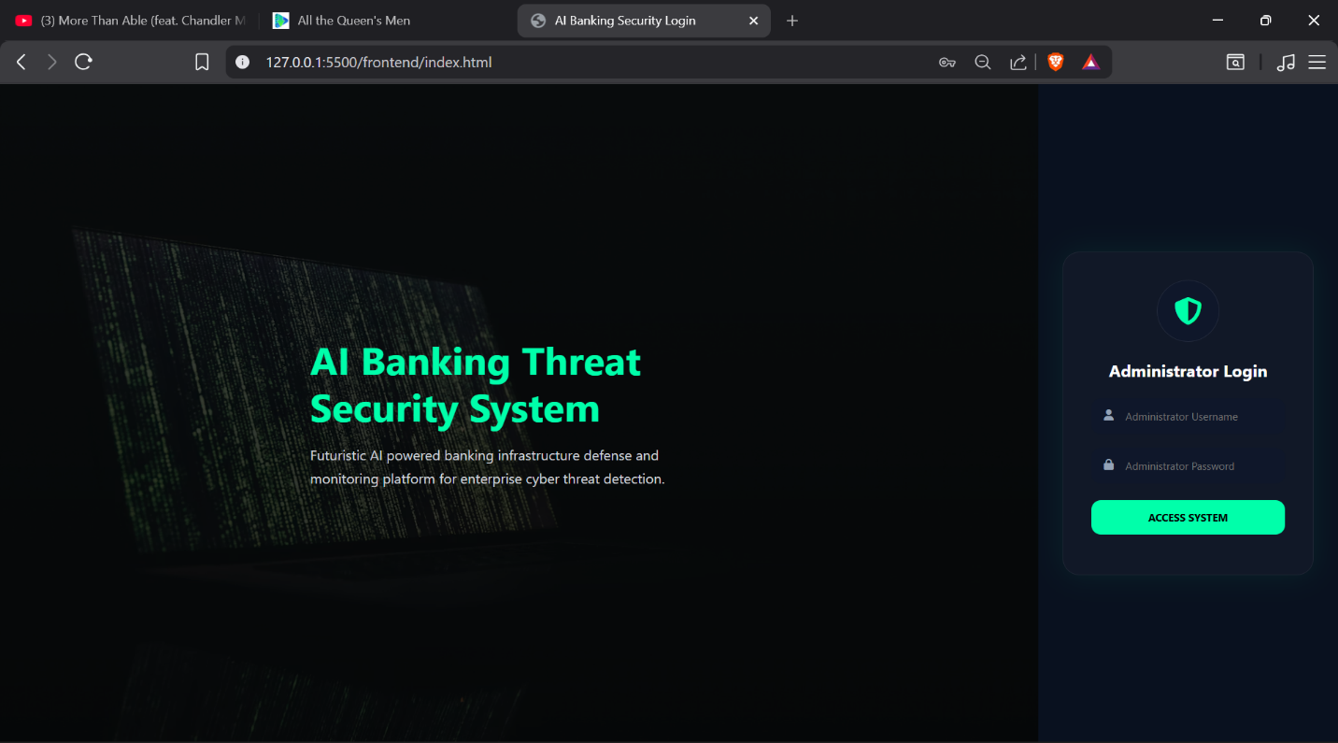
Figure 2.2.1: Login Page

2.2.2 Dashboard Interface
The Dashboard serves as the main control center of the system. It provides an overview of key metrics, system statistics, and analytical information generated by the platform.
Features include:
• System summary cards
• Risk indicators
• Confidence ratings
• Activity statistics
• Quick access navigation menu
• Real-time information display
The dashboard enables users to monitor system performance and access other modules from a single interface.
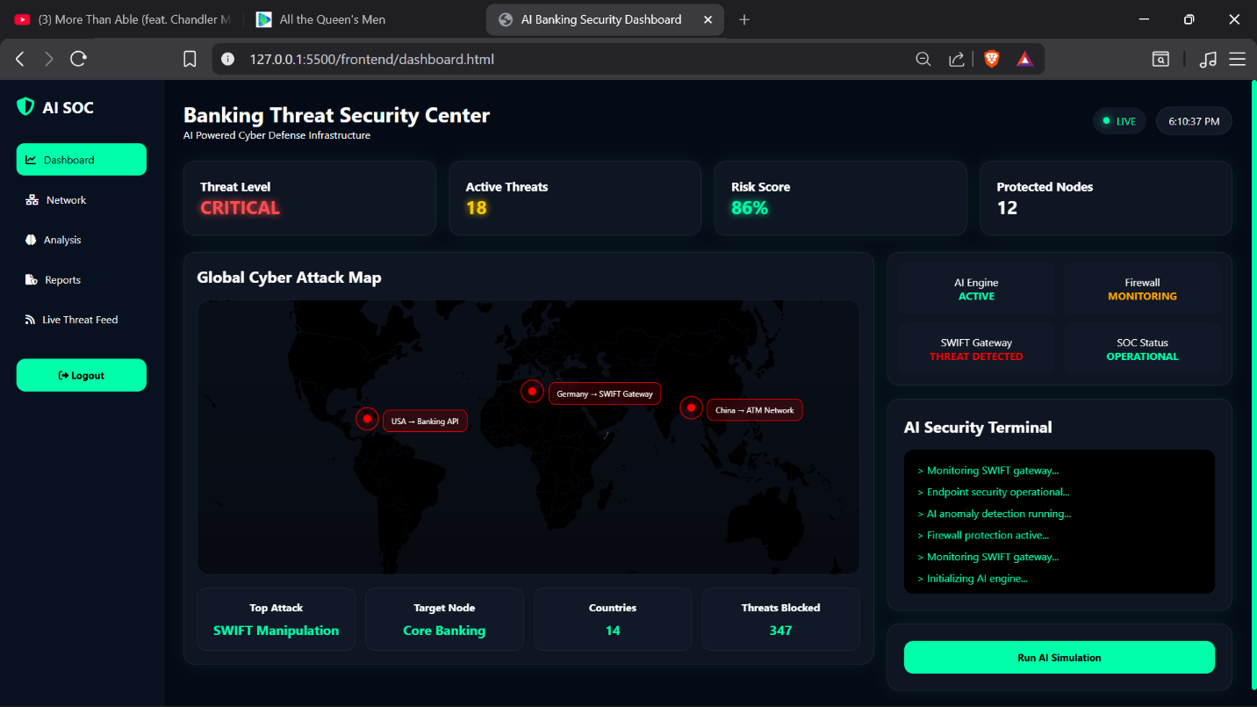
Figure 2.2.2: Dashboard Interface

2.2.3 Network Topology Interface
The Network Topology Interface provides a visual representation of interconnected system components and communication paths.
Features include:
• Network node visualization
• Connection mapping
• Status indicators
• Activity monitoring
• System structure overview
This page helps users understand relationships between various system components and monitor activity flow.
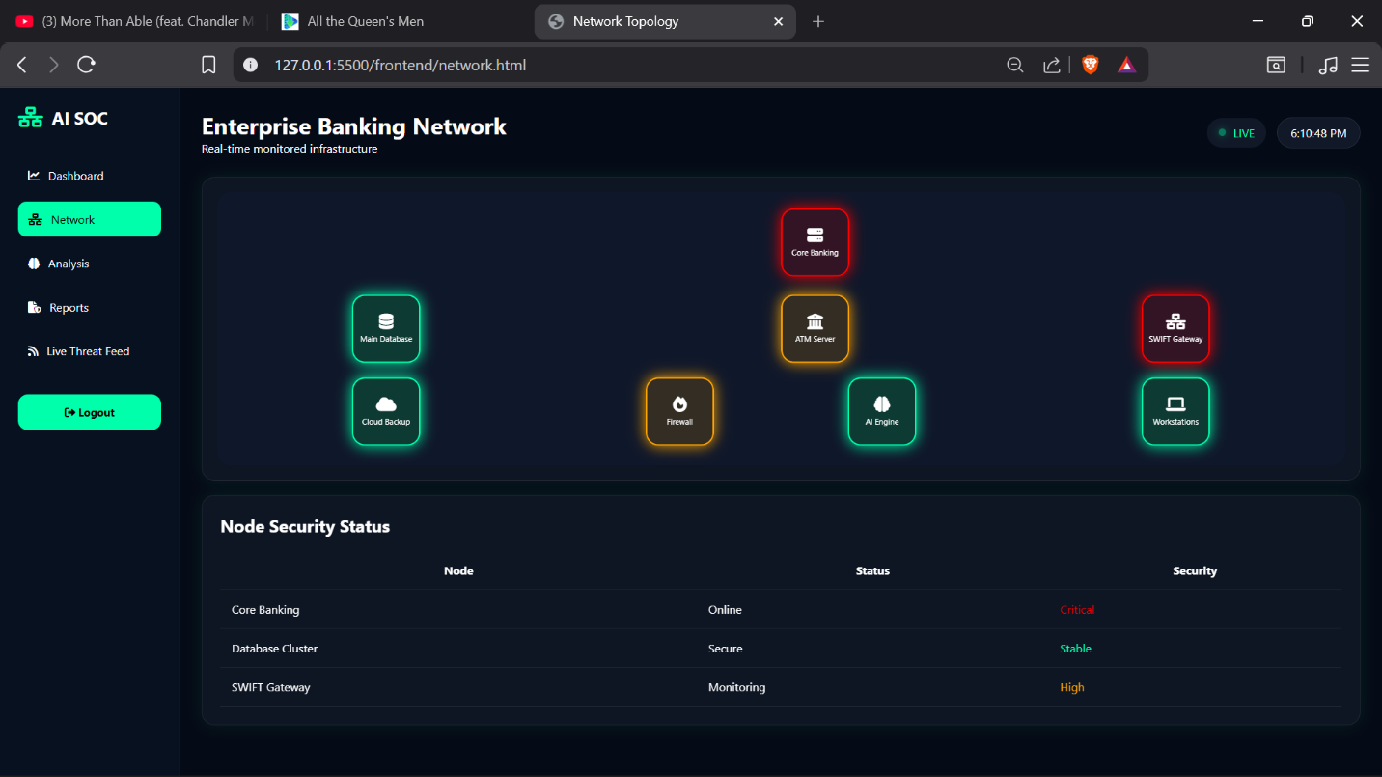
Figure 2.2.3: Network Topology Interface

2.2.4 AI Threat Analysis Interface
The AI Analysis Interface provides predictive analysis results generated by the system. It displays identified patterns, confidence levels, risk indicators, and recommended actions.
Features include:
• Predictive analysis results
• Risk score display
• AI confidence ratings
• Recommendation panel
• Activity assessment information
This page supports decision-making by presenting analytical insights in an understandable format.
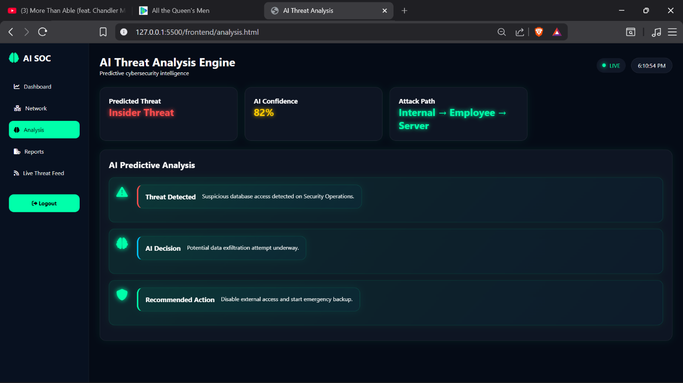
Figure 2.2.4: AI Analysis Interface

2.2.5 Reports Interface
The Reports Interface enables users to review historical records and generated reports. It provides summarized information regarding previous system activities and analysis outcomes.
Features include:
• Report generation
• Historical records
• Data summaries
• Activity logs
• Export options
This page helps users maintain records and evaluate system performance over time.
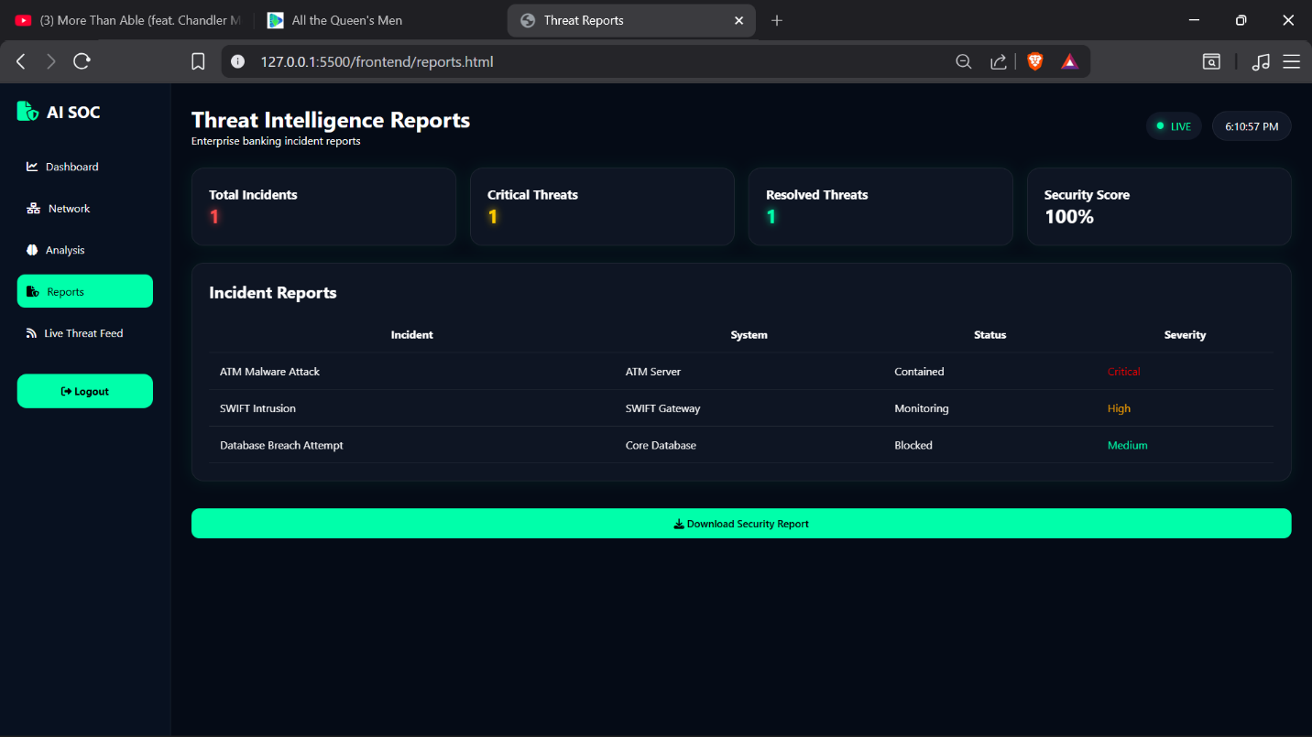
Figure 2.2.5: Reports Interface

2.2.6 Live Threat Feed Interface
The Live Feed Interface displays continuously updated activity information and generated alerts.
Features include:
• Live event feed
• Activity updates
• Status monitoring
• Event timestamps
• Alert notifications
This page allows users to monitor system activities in real time and respond to significant events promptly.
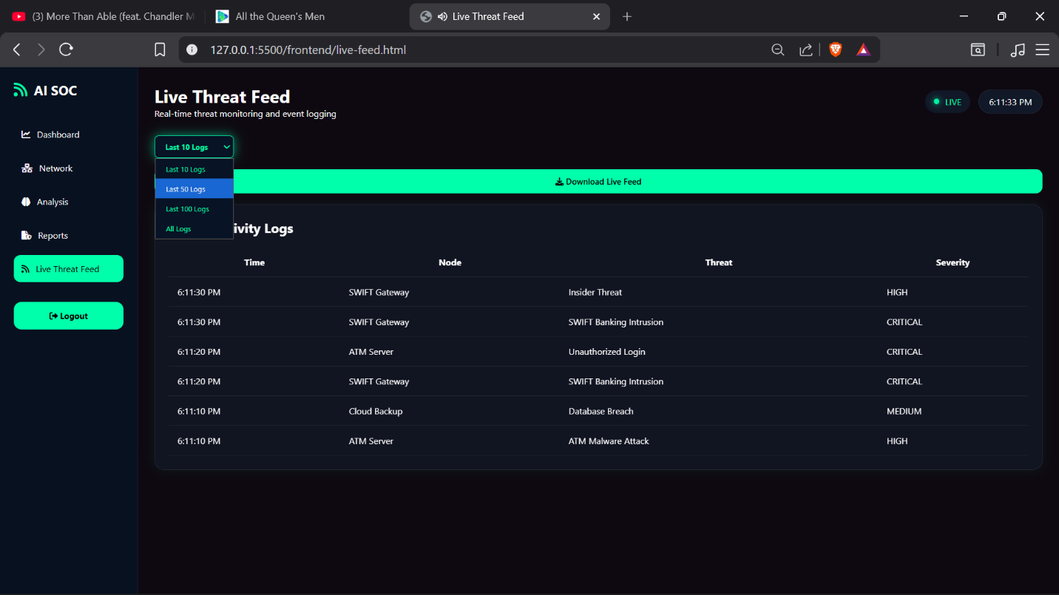
Figure 2.2.6: Live Threat Feed Interface

2.3 Logic Models

2.3.1 Login Authentication Flowchart
The Login Authentication Flowchart illustrates the process of validating user credentials before granting access to the system.
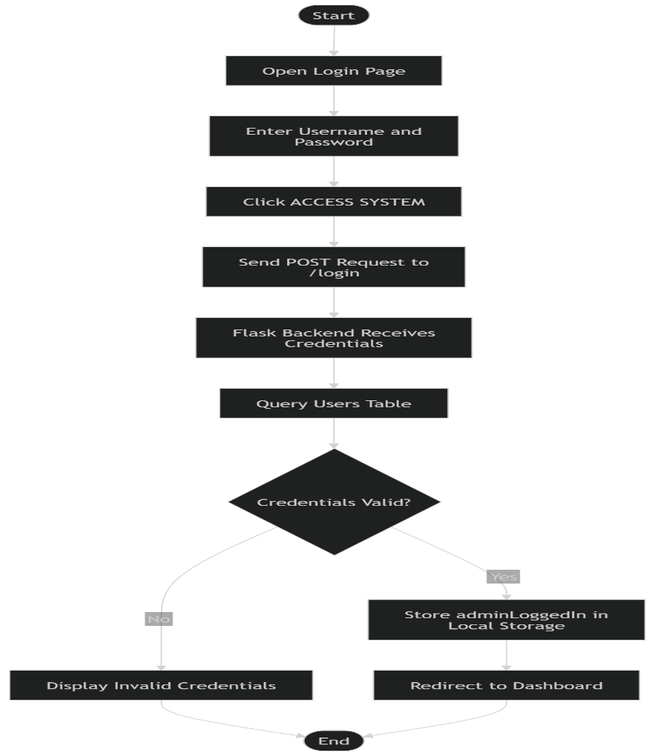
Figure 2.3.1: Login Authentication Flowchart

2.3.2 Predictive Analysis Flowchart
The Predictive Analysis Flowchart illustrates how system data is processed, analyzed, and transformed into predictions, confidence ratings, and recommendations.
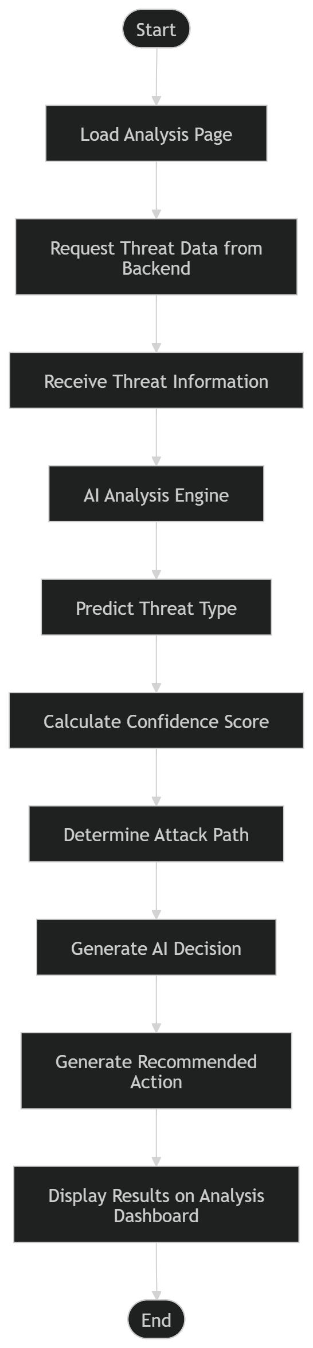
Figure 2.3.2: Predictive Analysis Flowchart

2.3.3 Activity Monitoring Flowchart
The Activity Monitoring Flowchart shows how activities are monitored, recorded, and displayed through the dashboard and live monitoring modules.
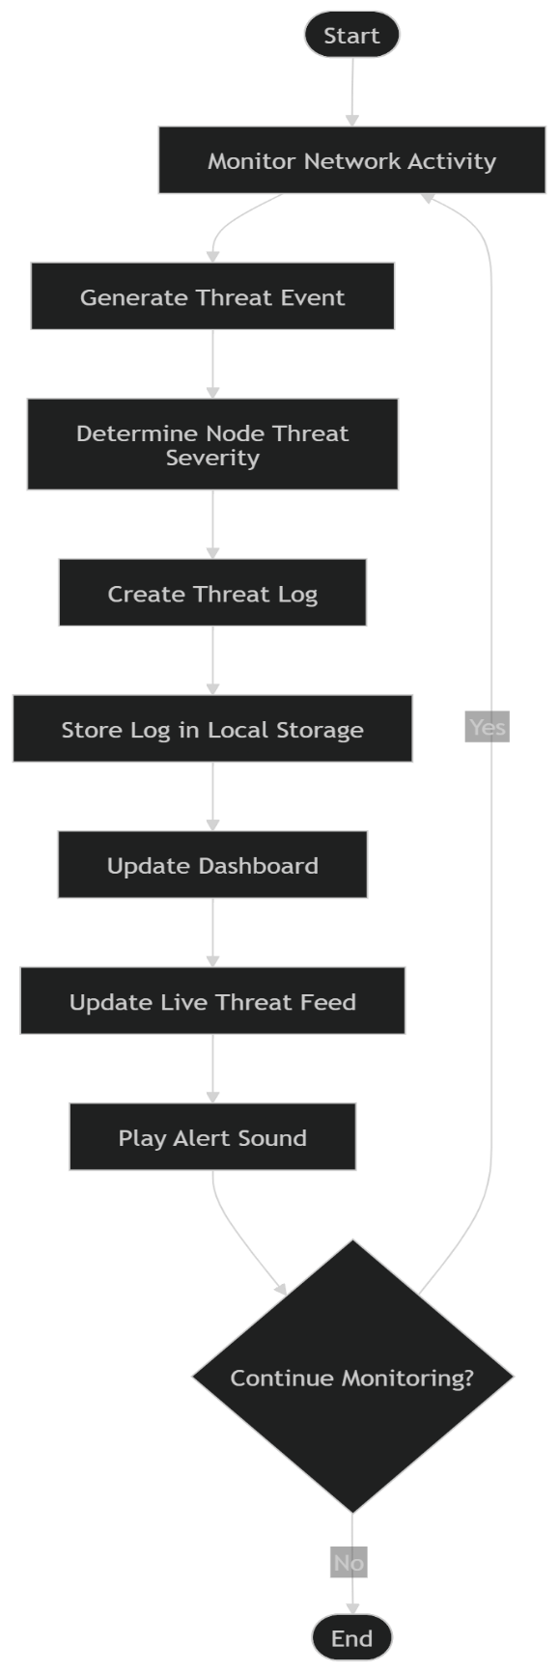
Figure 2.3.3: Activity Monitoring Flowchart

2.3.4 System Flow Diagram
The System Flow Diagram illustrates the interaction between users, the web interface, backend processing components, analysis modules, and the database.
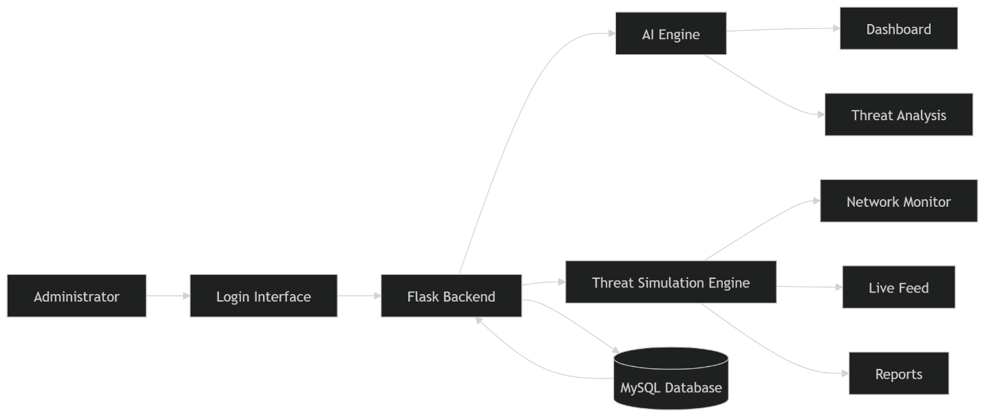
Figure 2.3.4: System Flow Diagram

2.3.5 Database Structure Diagram
The Database Structure Diagram illustrates the relationships between system tables, including users, activity logs, reports, and analysis records.
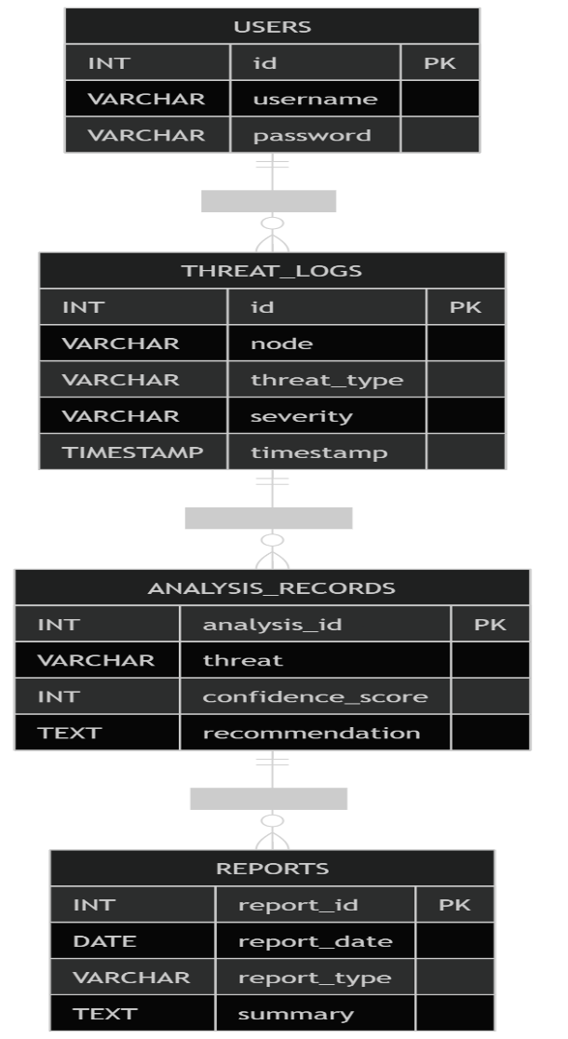
Figure 2.3.5: Database Structure Diagram

2.3.6 System Architecture Diagram
The System Architecture Diagram illustrates the overall architecture of the application, showing how the frontend, backend, analysis engine, and database communicate with one another.
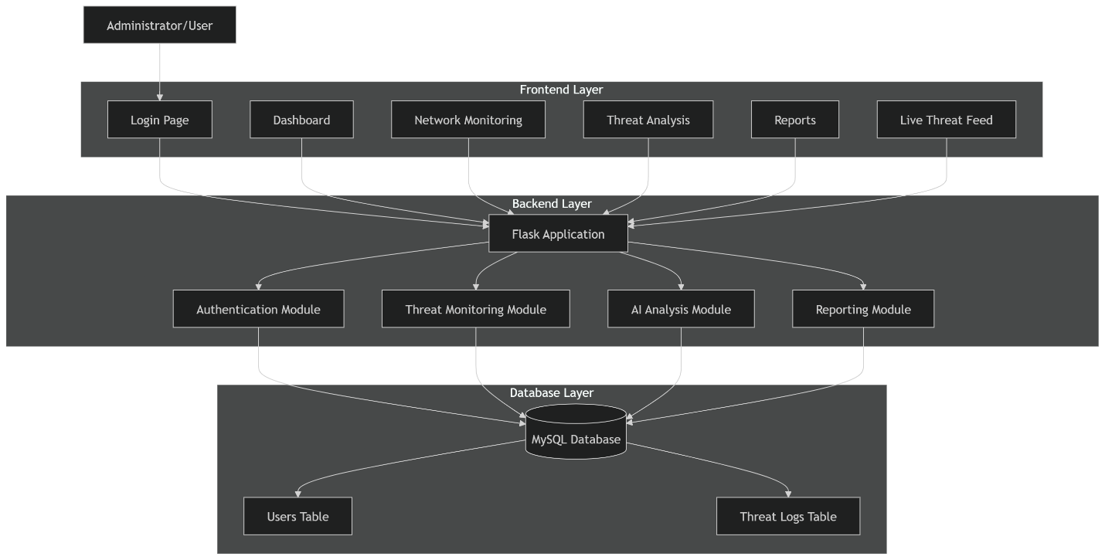
Figure 2.3.6: System Architecture Diagram

CHAPTER THREE: SYSTEM IMPLEMENTATION

3.1 Introduction
This chapter focuses on the development, testing, and deployment of the AI-Powered Predictive Analysis System. The system was developed to provide users with a centralized platform for monitoring activities, analyzing data patterns, generating predictive insights, and supporting decision-making through intelligent recommendations. The chapter describes the implementation of the user interface, backend logic, database integration, testing procedures, and deployment process used during system development.

3.2 User Interface Development
This section presents the development of the user-facing components of the system. The interface was designed to provide a modern, responsive, and user-friendly experience while enabling efficient access to all system functionalities.
The frontend was developed using HTML, CSS, and JavaScript. Several interfaces were created, including:
• Login Page for user authentication.
• Dashboard Interface for displaying system statistics, risk indicators, and analytical summaries.
• Network Topology Interface for visualizing interconnected system components.
• AI Analysis Interface for displaying predictive results, confidence ratings, risk scores, and recommendations.
• Reports Interface for viewing historical records and generated reports.
• Live Feed Interface for monitoring activities and events in real time.
The interface design emphasizes usability, accessibility, and efficient navigation between system modules.

3.3 Logic Development
This section describes the development of the backend logic responsible for processing requests, managing data, and generating analysis results.
The backend was developed using Python and the Flask framework. The system logic performs the following functions:
• User authentication and login validation.
• Data processing and management.
• Activity monitoring and logging.
• Generation of risk indicators and confidence ratings.
• Predictive analysis of activity patterns.
• Generation of intelligent recommendations.
• Report generation and retrieval.
• Communication between the frontend and database.
The backend interacts with the MySQL database to store and retrieve information while ensuring efficient system performance.

3.4 Testing
The AI-Powered Predictive Analysis System was tested to verify functionality, usability, reliability, and performance.
- Testing Scenarios Conducted:
- User login and authentication.
- Dashboard loading and data display.
- Predictive analysis generation.
- Risk score calculation and display.
- AI confidence rating generation.
- Recommendation generation.
- Activity logging and retrieval.
- Report generation and viewing.
- Navigation between system modules.
- Responsive user interface testing on multiple browsers.
Test Results Summary:
- All major system functions operated successfully.
- User authentication worked correctly.
- Analysis results were generated and displayed as expected.
- Risk indicators and confidence ratings were calculated successfully.
- Reports and activity logs were accessible.
- User interface responsiveness was maintained across supported browsers.
- No critical system errors were encountered during testing.

Test Case | Expected Result | Actual Result | Status
Login Authentication | User gains access | Works correctly | Pass
Dashboard Loading | Dashboard displayed | Works correctly | Pass
Predictive Analysis | Analysis generated | Works correctly | Pass
Risk Score Generation | Risk score displayed | Works correctly | Pass
AI Recommendation | Recommendation generated | Works correctly | Pass
Report Generation | Report displayed | Works correctly | Pass
Activity Logging | Activity stored and displayed | Works correctly | Pass
Table 3.4 Testing Results

3.5 Deployment

The AI-Powered Predictive Analysis System was deployed as a web-based application using modern web development technologies. The frontend was developed using HTML, CSS, and JavaScript, while Flask was used for backend development. MySQL was used for database management and storage of system information.
The system was configured for local and web-based execution, allowing users to access the platform through a web browser. Deployment involved configuring the application environment, database connectivity, and system dependencies to ensure reliable operation.
System URL:

CHAPTER FOUR: CONCLUSION AND RECOMMENDATION

4.1 Conclusion
In conclusion, the AI-Powered Predictive Analysis System successfully achieved its intended objectives of providing a centralized platform for monitoring activities, analyzing information, generating predictions, and supporting decision-making through intelligent recommendations. The system was developed as a web-based application that integrates data visualization, predictive analysis, reporting, and activity monitoring into a single user-friendly environment.
The project demonstrated the practical application of software development concepts, including frontend development, backend programming, database management, and system integration. Through the implementation of dashboards, analysis modules, reporting features, and monitoring interfaces, the system provides users with meaningful insights that can assist in understanding patterns and making informed decisions.
The development process also provided valuable experience in web application development using HTML, CSS, JavaScript, Python, Flask, and MySQL. Various challenges were encountered during implementation, including interface design, database connectivity, and system integration, but these were successfully resolved through testing, debugging, and continuous improvement.
Overall, the system provides an effective prototype that demonstrates how predictive analysis and intelligent recommendations can be integrated into a modern web application. The project successfully meets its objectives and serves as a foundation for future enhancements and research in predictive systems and intelligent decision-support technologies.

4.2 Recommendation
Although the AI-Powered Predictive Analysis System functions effectively as a prototype, several improvements can be implemented in future versions to enhance its functionality and overall performance.
- Advanced Predictive Models
Future versions of the system can incorporate more sophisticated machine learning and artificial intelligence algorithms to improve prediction accuracy and generate more detailed analytical results.
- Enhanced Data Visualization
Additional charts, graphs, and interactive dashboards can be introduced to provide users with deeper insights and a better understanding of system-generated information.
- Real-Time Data Processing
The system can be enhanced to support real-time data collection and processing, enabling users to receive instant updates and analysis results.
- Improved User Management
Future implementations can include multiple user roles, permission management, and advanced authentication mechanisms to improve security and access control.
- Mobile Compatibility
A dedicated mobile version or mobile application can be developed to allow users to access system features conveniently from smartphones and tablets.
- System Scalability
The platform can be optimized to support larger datasets and a greater number of concurrent users, making it suitable for deployment in larger organizational environments.
- Cloud Integration
Cloud-based storage and deployment services can be integrated to improve accessibility, reliability, backup management, and overall system performance.
By implementing these improvements, the system can evolve into a more robust, scalable, and intelligent platform capable of supporting a wider range of applications and user requirements.

REFERENCES
Flask Documentation. (n.d.). Flask Web Framework Documentation. https://flask.palletsprojects.com/
MySQL Documentation. (n.d.). MySQL Reference Manual. https://dev.mysql.com/doc/
MDN Web Docs. (n.d.). HTML Documentation. https://developer.mozilla.org/en-US/docs/Web/HTML
MDN Web Docs. (n.d.). CSS Documentation. https://developer.mozilla.org/en-US/docs/Web/CSS
MDN Web Docs. (n.d.). JavaScript Guide. https://developer.mozilla.org/en-US/docs/Web/JavaScript/Guide
Python Software Foundation. (n.d.). Python Documentation. https://docs.python.org/
W3Schools. (n.d.). HTML Tutorial. https://www.w3schools.com/html/
W3Schools. (n.d.). CSS Tutorial. https://www.w3schools.com/css/
W3Schools. (n.d.). JavaScript Tutorial. https://www.w3schools.com/js/
W3Schools. (n.d.). Python Tutorial. https://www.w3schools.com/python/
Visual Studio Code. (n.d.). Visual Studio Code Documentation. https://code.visualstudio.com/docs
OpenAI. (2026). ChatGPT. https://chatgpt.com/
Oracle Corporation. (n.d.). MySQL Database Documentation. https://dev.mysql.com/doc/

